**SHolsProject checkpoint 3**

Each group must submit a pdf file that includes the following:

1. The ER diagram. Please state if this one is a revised one. If it is revised, please discuss **where you revised it, and why**. If it is not revised, **please state that it has not been revised.**

**NOT Revised**

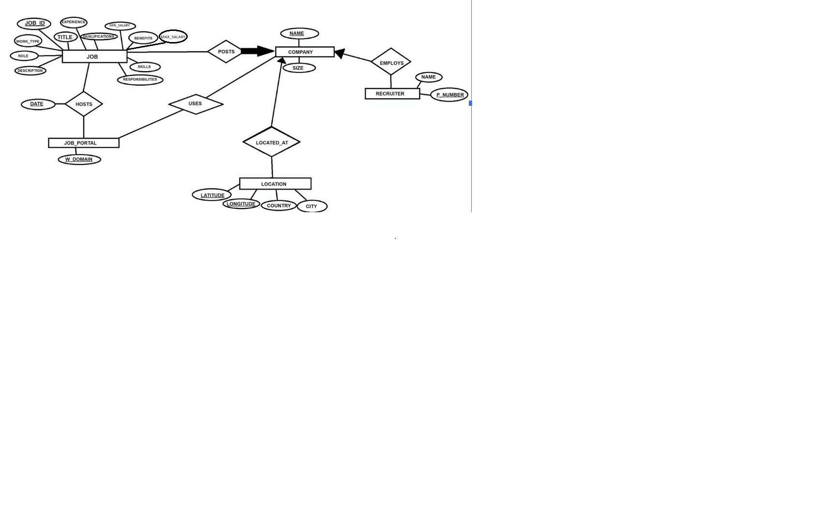

1. The relational schema of your database. For each table, specify all keys that are applicable and designate one key as the primary key. For example, you can write:

Job(Job_ID (Primary key): string, Title: string, Experience: string, Qualifications: string, Min_Salary: big int, Max_Salary: big int, Work_Type: string, Role: string, Description: string, Benefits: string, Skills: string, Responsibilities: string, Company_Name: string)

Job Portal(W_Domain (Primary key): string)

Company(Name (Primary key): string, size: big int)

Location(Latitude (Primary key): double, Longitude (Primary key): double, Country: string, City: string, Company_Name: string)

Recruiter(R_Name: string, Phone_Number (Primary key): string, Company_Name: string)

Hosts(Job_ID: string, W_Domain: string, Date: date)

Uses(Company_Name: string, W_Domain: string)

1. List all non-trivial functional dependencies that are applicable. Try to ensure that all tables in your schema are in **third normal form (3NF)**. If a table is not in 3NF, please explain the reason why you make that design decision.

3NF: Check FDs. If the left side is a superkey, move on. Otherwise, check if the right side is part of any key. All FDs must pass

Job {Job_ID → Title, Experience, Qualifications, Salary, Work_Type, Role, Description, Benefits, Skills, Responsibilities, Company_Name}

Job_Portal { }

Company {Name → Size}

Location {Longitude, Latitude → Country, City, Company_Name}

Recruiter {Phone_Number → R_Name, Company_Name}

Hosts {Job_ID → Website_Domain, Date}

Uses { }

1. Describe the final choice for software platforms/languages that you will be using.

We plan to use C++ for the language, and QT for the implementation. QT has been used by many big name companies, proving the software is complex and has few limitations on design. MySQL will be used for the database as it works well with C++.

1. Describe the labor division among group members. This could be the same as you have described in checkpoint 1 but this could be different to accommodate the dynamics in team work.

Brogan Murray - Frontend Developer / Backend Developer

Corban Larson - Backend Developer

Jake Cramer - Frontend Developer / Project Manager

As the project progresses, roles may be changed